+    Certificato CSQ n. 9190 SIL6  80014 Giugliano (NAPOLI) Italy | Data Sheet | 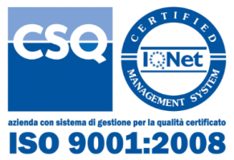
 | Rabbit Kit

Rabbit Kit
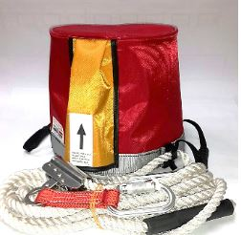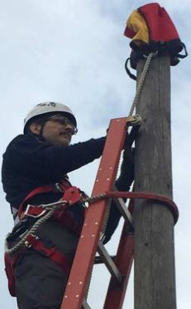

Features:
Description: | Rabbit Kit for ascent, parking and descent with ladders on wooden and fiberglass pole, allows the operator to create an anchor point, in a few seconds, at the top of the pole in order to allow safe handling on the same.  the kit consists of:  - A cap containing the transportable storage device EN 795 cl.b with an integrated fall arrest device EN 353.2  Weight: 1.560 kg  - A non-conductive telescopic pole suitable for lifting, positioning and removing the container cap of the entire system equipped with a containment bag.  Weight: 3.500 kg  Assembled rod length: 120 cm
Performance: | The kit is CE certified, according to EN353.2 and EN 795 cl.b.  Its maximum range, including therefore the operator and equipment is daN: 120.

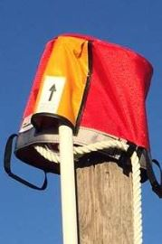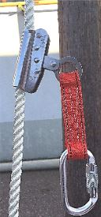
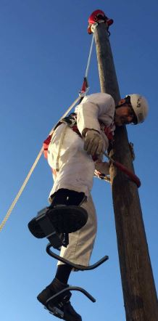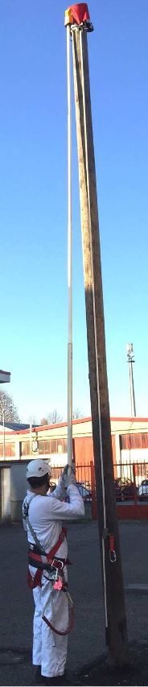
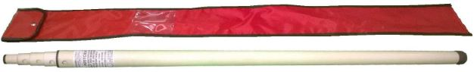

S.I.L.T.I. SUD S.p.A. | Rabbit Kit | Data Sheet

